

**Symbiosis Skills and Professional University Kiwale, Pune**

------------------------------------------------------------------------------------------

**PROJECT REPORT**

**On**

**“Traffic Signs Recognition”**

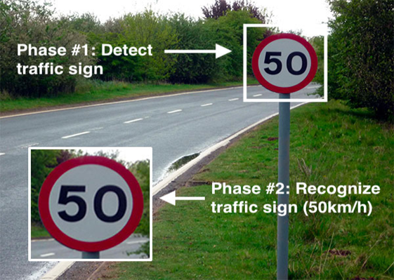

**Submitted by**

**Mrs . Sneha Sudhir Hashilkar**

**(Registration Number : 2001207074)**

**DA-Batch-II**

**Under The Guidance of**

**Trainer's Name: Mr. Kushal Sharma**

**STUDENT DECLARATION AND ATTESTATION BY TRAINER**

This is to declare that this report has been written by me. No part of the report is plagiarized from other sources. All information included from other sources have been duly acknowledged. I aver that if any part of the report is found to be plagiarized, I shall take full responsibility for it.

Signature of student

**Name of student: Mrs. Sneha Sudhir Hashilkar**

Registration Number: 2001207074

Signature of trainer

**Name of trainer: Mr. Kushal Sharma**

**CERTIFICATE**

This is to certify that the report entitled, “**Traffic Signs Recognition**” submitted by ”Mrs. Sneha Sudhir Hashilkar” to Symbiosis Skills and Professional University, Pune, Maharashtra, India, is a record of bonafide Project work carried out by him under my supervision and guidance and is worthy of consideration for the completion of certificate course in ‘Data Associate”.

Signature of Trainer

Name of Trainer : Kushal Sharma

Date: / / 2021

__________________ __________________

Supervisor Supervisor

Date:

**ACKNOWLEDGEMENTS**

This is to acknowledge all those without whom this project would not have been reality. Firstly, I would wish to thank our Trainer Mr. Kushal Sharma sir who gave his immense support, dedicated his time towards it and made us understand how to make this project. Without his guidance, the project would not have been complete.

A project is a bridge between theoretical and practical learning and with this thinking I worked on the project and made it successful due to timely support and efforts of all who helped me.

Once again, I would like to put my gratitude and sincere thanks to DR. Shravan Kadvekar for giving me this opportunity.Then I would also like to thank my classmates and my friends also for their encouragement and help in designing and making my project creative.Only because of them I was able to create my project and make it a good and enjoyable experience.

**INDEX (Sample)**

|  |  |  |  |  |
| --- | --- | --- | --- | --- |
|  | | | | |
| **Sl. No** | **Index** |  |  | **Page No** |
| 1 | **Acknowledgement** | |  | 4 |
| 2 | **Purpose And Problem Statement** | |  | 6 |
|  | 2.1 | Purpose of Project | | 7 |
|  | 2.2 | Problem Statement | | 8 |
| 3 | **Objective of the Project** | | | 9 |
|  | 3.1 | General Objective | | 10 |
|  |  |  | | |
| 4 | **Strategy and Steps Performed** | | | 11 |
|  | 4.1 | Algorithm Used | | 12 |
|  | 4.2 | Architecture | | 13 |
|  | 4.3 | Implementation | | 14 |
|  | 4.4.1 | Data Source | | 15 |
|  | 4.4.2 | My SQL and Hive Data Base Description 16 | | |
|  | 4..4.3 | MySQL to HDFS ETL Tool(Sqoop) 18 | | |
|  | 4.4.4 | Reporting 23 | | |
| 5 | **Output** | | | 20 |
|  | 5.1 | GUI Representation 21 | | |
| 6 | **Future Scope and Conclusion** | | | 23 |

**2.**

**PURPOSE AND PROBLEM STATEMENT OF PROJECT**

**Purpose Of Project**

Traffic signs are an essential part of our day to day lives. They contain critical information that ensures the safety of all the people around us. Without traffic signs, all the drivers would be clueless about what might be ahead to them and roads can become a mess. The annual global roach crash statistics say that over 3,280 people die every day in a road accident. These numbers would be much higher in case if there were no traffic signs.

On the other hand, researchers and big companies are working extensively on proposing solutions to self-driving cars. Just to name a few these include Tesla, Uber, Google, Audi, BMW, Ford, Toyota, Mercedez, Volvo, Nissan, etc. These autonomous vehicles need to follow the traffic rules and for that, they have to understand the message conveyed through traffic signs.

Every country has some standards set for the design of different traffic signs like U-turn, Left-turn, Right-turn, No-entry, etc. Traffic sign recognition is the process of automatically identifying which of the following class the sign belongs to. The earlier Computer Vision techniques required lots of hard work in data processing and it took a lot of time to manually extract the features of the image. Now, deep learning techniques have come to the rescue and today we will see how to build a traffic recognition system for autonomous vehicles.

**Problem Statement**

* To propose a method to extract the image frames
* To propose a method to remove the effect of the different illuminations on
* extracted image frames.
* To propose an algorithm to identify the regions of interest
* To propose a method to extract the symbol of the traffic warning sign
* To propose a method to identify the symbol of the traffic warning sign.

**3.**

**OBJECTIVE OF PROJECT**

**General Objective**

Identification of the Region of interest

After capturing a single image frame from a video segment, the regions of interest can

be identified. These regions are the candidate regions which may be a traffic warning signs. To

identify these regions, first it should threshold the Normalized RGB image and then median

filter should be applied to remove the noise. Figure 1.1 illustrates the Region of interest for a

particular image frame.

Extracting the symbol of the warning sign

After extraction of the Regions of interest, each region is further analyzed to extract the

symbol of the warning sign. Compliment the logical images, removing the regions attached

with the image border are some of the techniques which were used for this purpose.

illustrates the extracted symbol after analyzing a single candidate region.

Recognition of the Traffic warning sign

After extracting the symbol of the warning sign, there are several methods (that can be

used) to identify the traffic warning signs. Template matching techniques and pattern

recognition techniques using neural networks are some of the complex techniques which have been used for this at the previous related works. (But these methods are having lot of difficulties at the implementation process, and the target of this research work was to develop an algorithm which can be easily implemented). But (Therefore,) in this research work, simple mathematical techniques (matrix theory) were used to identify the traffic warning signs..

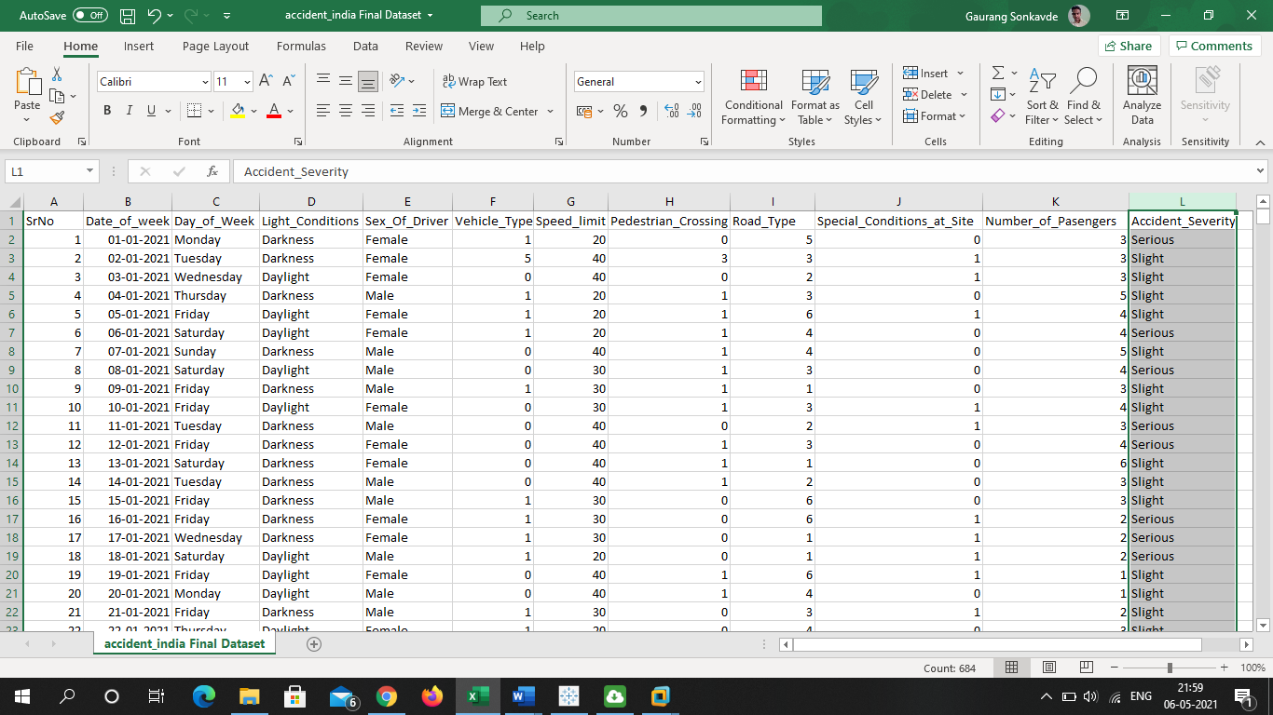

**4.**

**Steps and Stratergies Performed**

**Algorithm Used**

CNN (Convolutional Neural Network) Algorithm

CNN is a type of deep learning model for processing data that has a grid pattern, such as images, which is inspired by the organization of animal visual cortex and designed to automatically and adaptively learn spatial hierarchies of features, from low- to high-level patterns.

CNN is a mathematical construct that is typically composed of three types of layers (or building blocks): convolution, pooling, and fully connected layers. The first two, convolution and pooling layers, perform feature extraction, whereas the third, a fully connected layer, maps the extracted features into final output, such as classification.

A convolution layer plays a key role in CNN, which is composed of a stack of mathematical operations, such as convolution, a specialized type of linear operation. In digital images, pixel values are stored in a two-dimensional (2D) grid, i.e., an array of numbers, and a small grid of parameters called kernel, an optimizable feature extractor, is applied at each image position, which makes CNNs highly efficient for image processing, since a feature may occur anywhere in the image. As one layer feeds its output into the next layer, extracted features can hierarchically and progressively become more complex.

The process of optimizing parameters such as kernels is called training, which is performed so as to minimize the difference between outputs and ground truth labels through an optimization algorithm called backpropagation and gradient descent, among others.

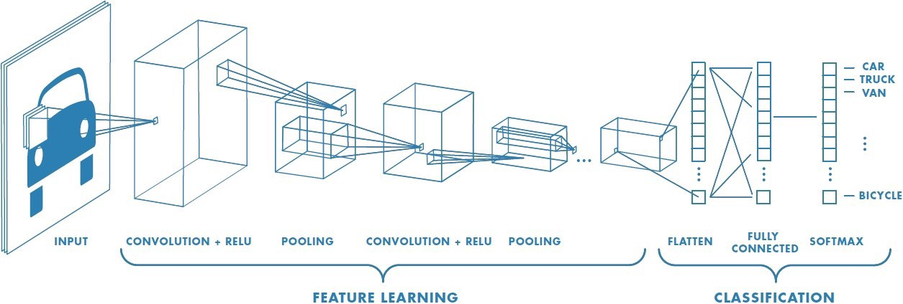

# 4.1 Architecture:

The Dataflow is as follows:

1. We made a Project where we used Deep Learning also we used Keras and made an Project which will Identify Traffic signal with help of an Machine learning Algorithm called as CNN (Convolution Neural Network) also after that we made a GUI(Graphic User Interface) where I we need to upload Images and with the help of Dataset Traffic Sign is identified.
2. After that we download Data from Kaggle which we will use for Accident Analysis of India which is an CSV File and will have all the features.
3. These csv files will be loaded to MySQL Database for Data Querying.
4. Later this data is exported to Apache Hadoop (Hadoop Distributed File Storage) using Sqoop (ETL tool).
5. Again using Sqoop command we store or import that Accident Analysis CSV File to Hive which is Data Warehouse.
6. Data is then used for Reporting and after that we analyze the data set and built an Dashboard on Power BI and Tableau and after that Report it.

Machine Learning Jupyter Notebook

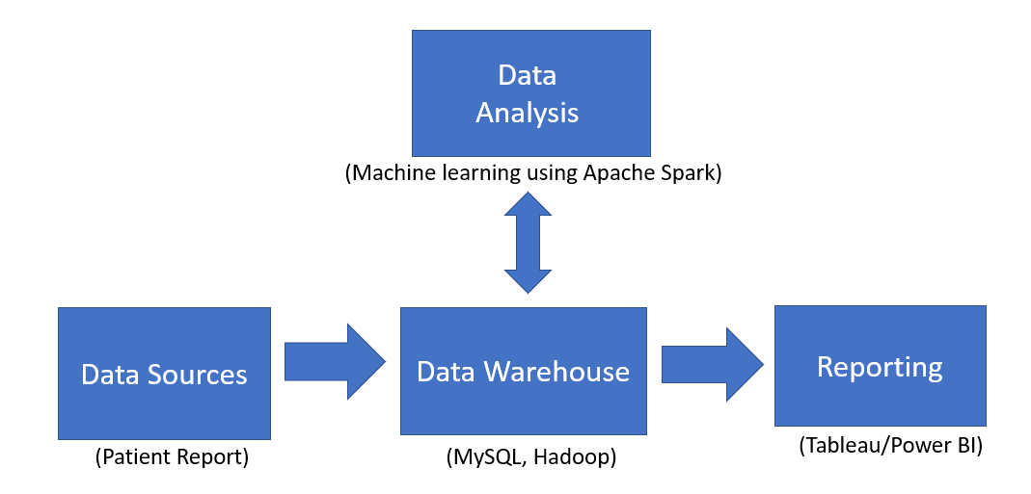

Power BI , Tableu

My SQL , Hadoop , Hive

Trafic Sign Data Set

Accident_Analysis data Set

# 4.2 Implementation:

The implementation details are shared according to the dataflow mentioned in section 3.1.

1. Data Sources:

With the help of Kaggle we downloaded data in CSV File for accident Analysis and Image Data set of Traffic Signs to Jupyter Notebook .The CSV files are then uploaded to MySQL database.

1. MySQL database Description:

We have created a database named “Accident Analysis”, which contains table “Accidents_India” which hasAccident_India data mentioned in section The data is loaded with the CSV file mentioned in the MySQL Source file (.sql). also later we uploaded that data in HDFS and Hive.

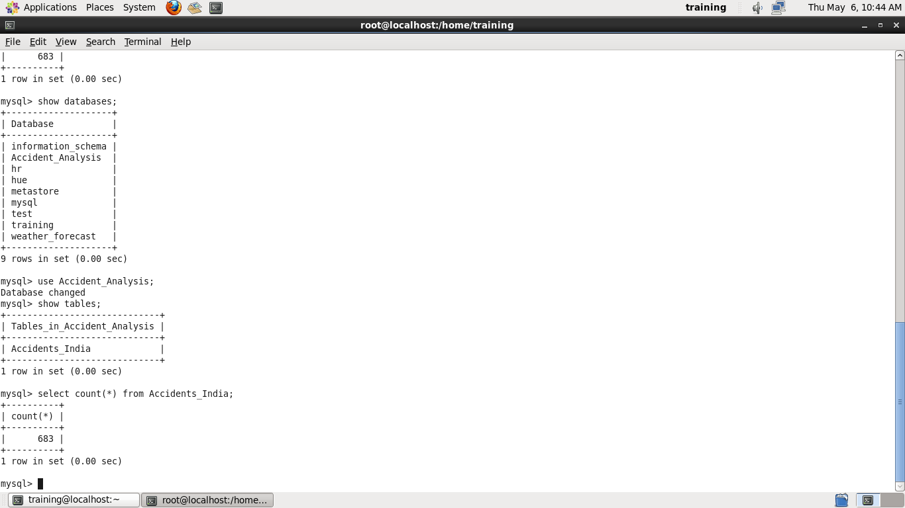

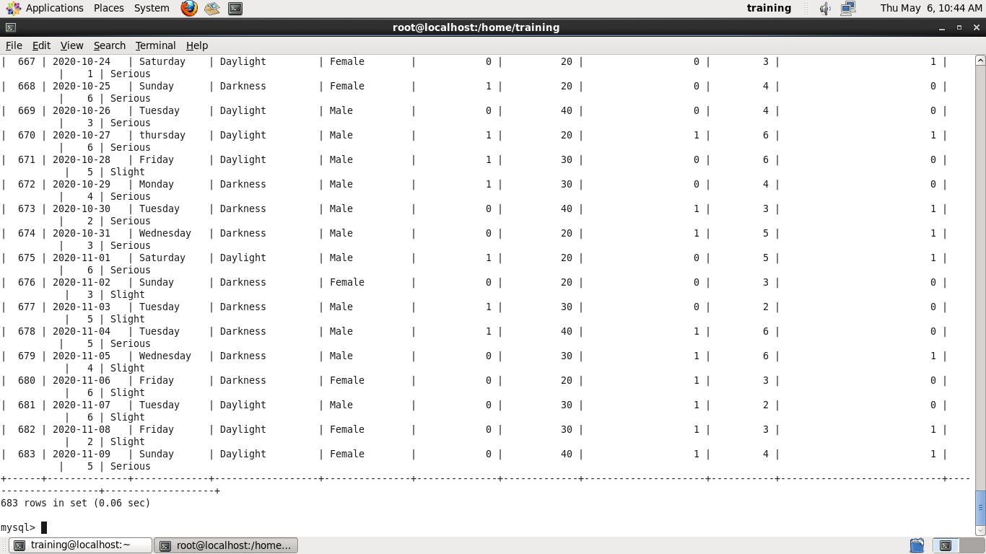

Screenshot: SQL

1. MySQL to HDFS using Sqoop ETL tool:

With the use of Sqoop, I have transferred the cleveland table from MySQL to HDFS at /HeartA/.

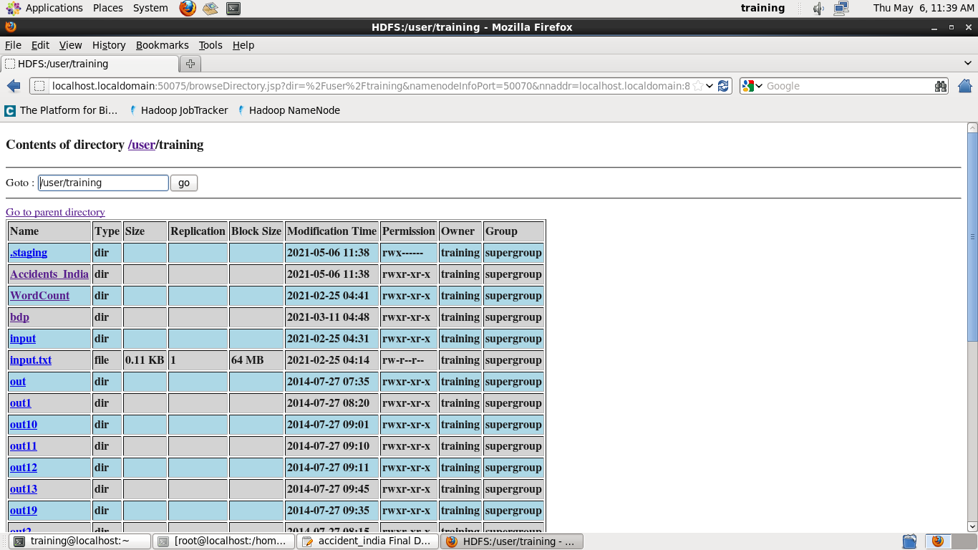

Screenshot : HDFS

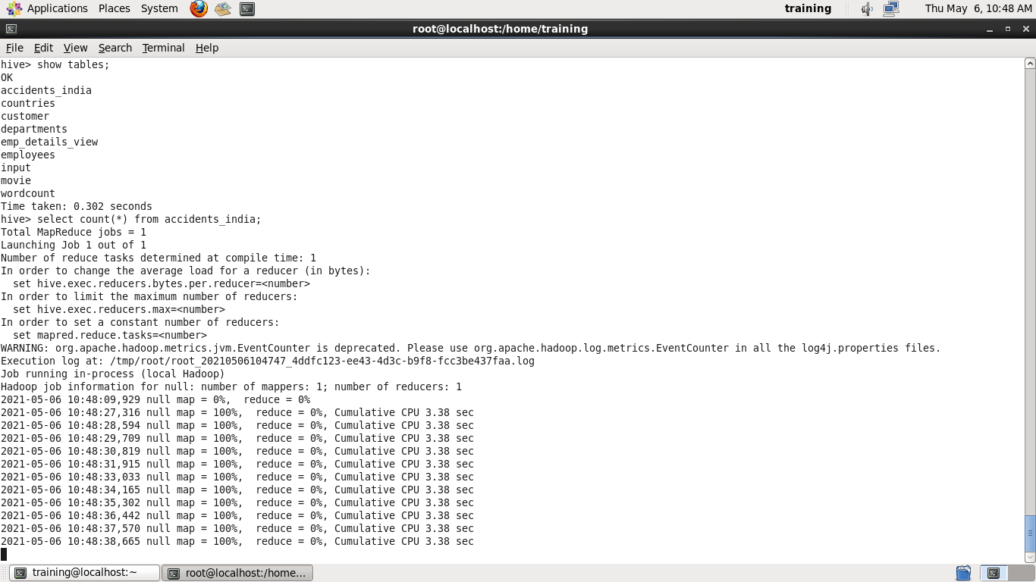

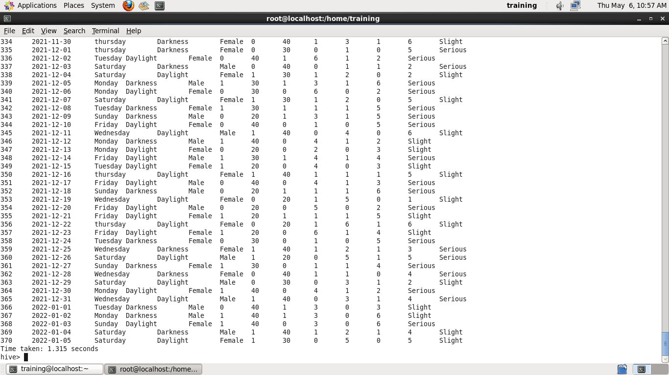

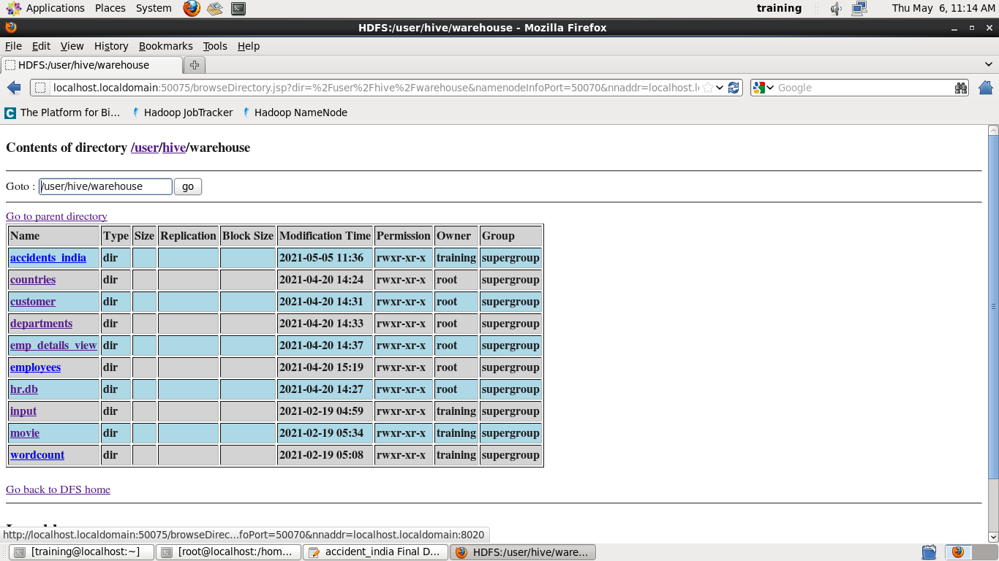

Screenshot: HIVE

1. Machine Learning:

With Jupyter Notebook ML library, we created a Classification Neural Network Model using KERAS and Deep Learning. By splitting the dataset in 80-20 ratio, we trained our Model with 80% of Train Dataset and the rest was used for testing our model. Later we made an GUI and by using that we can classify Traffic Signs.

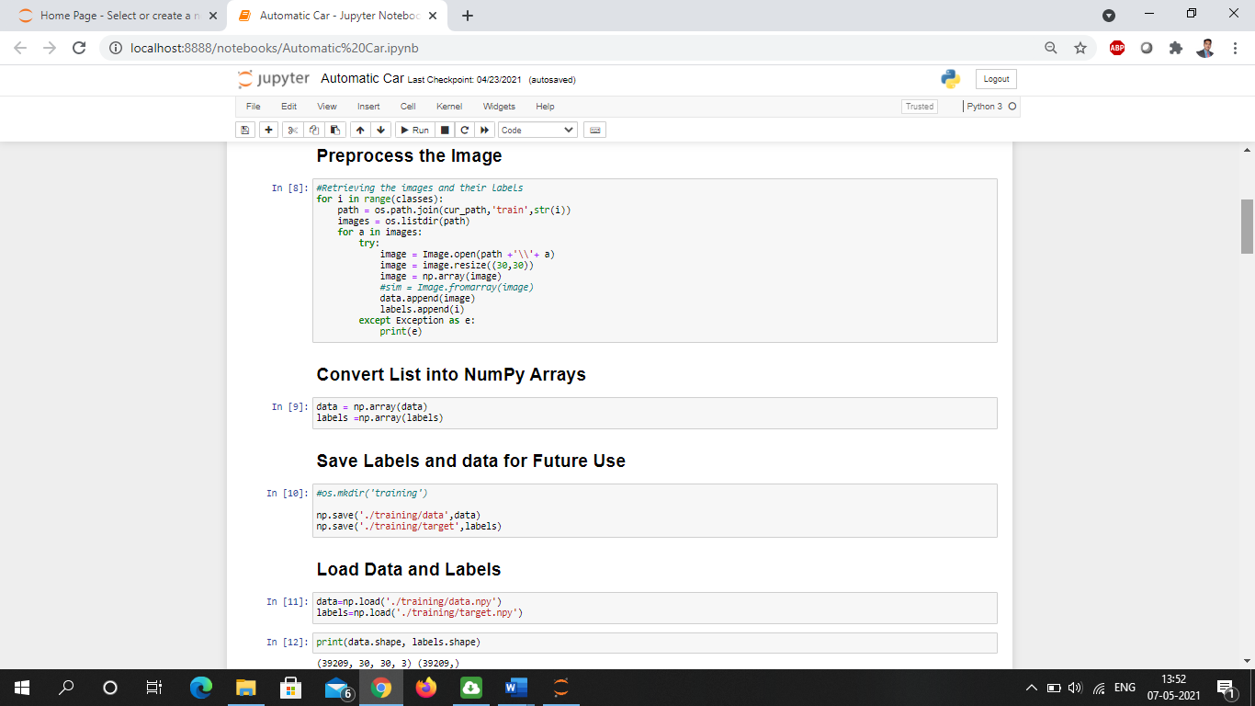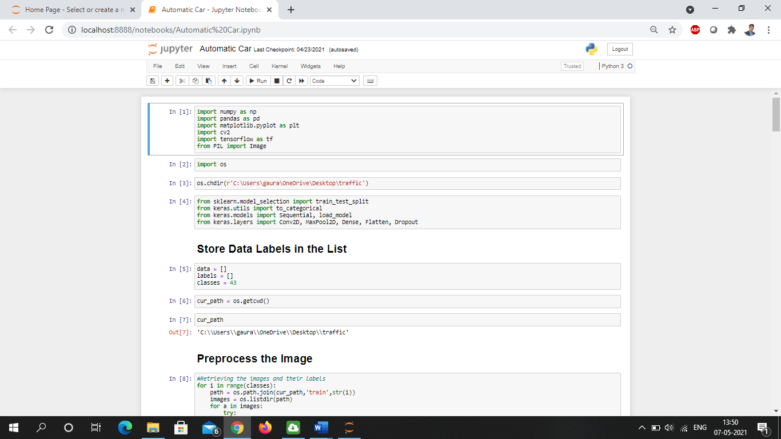

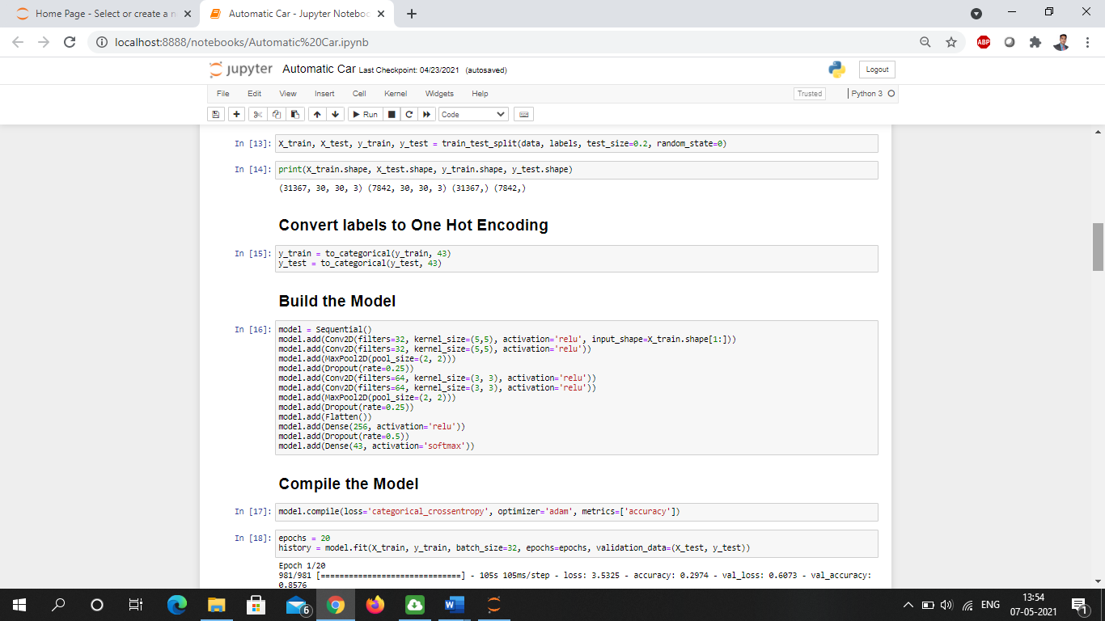

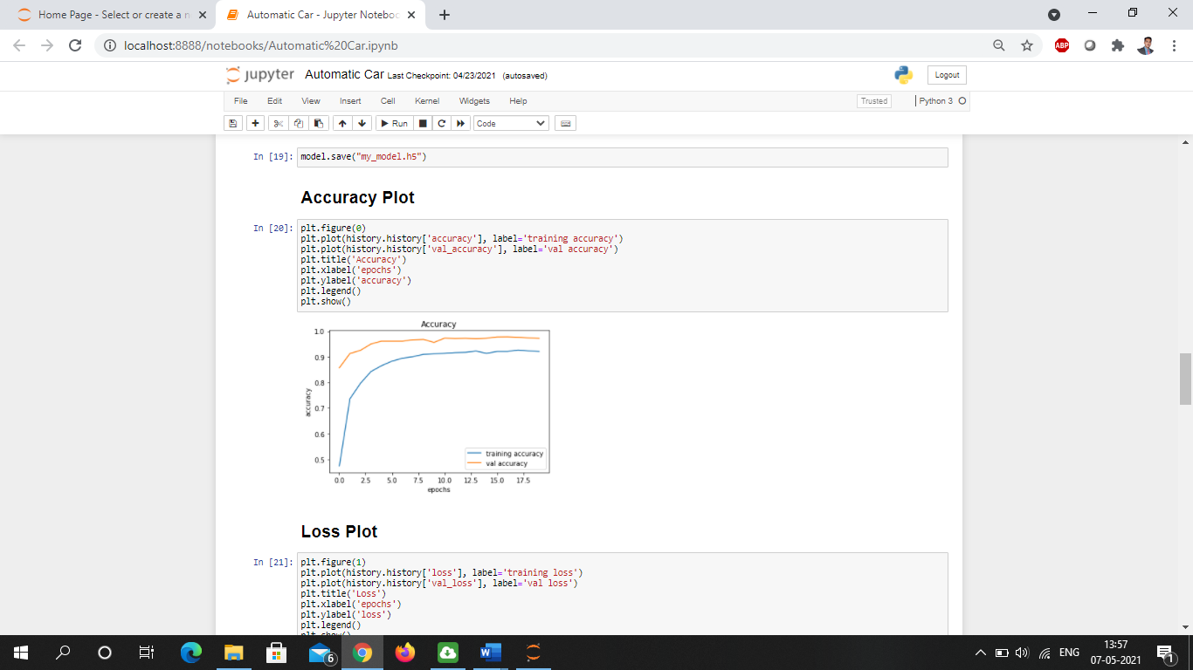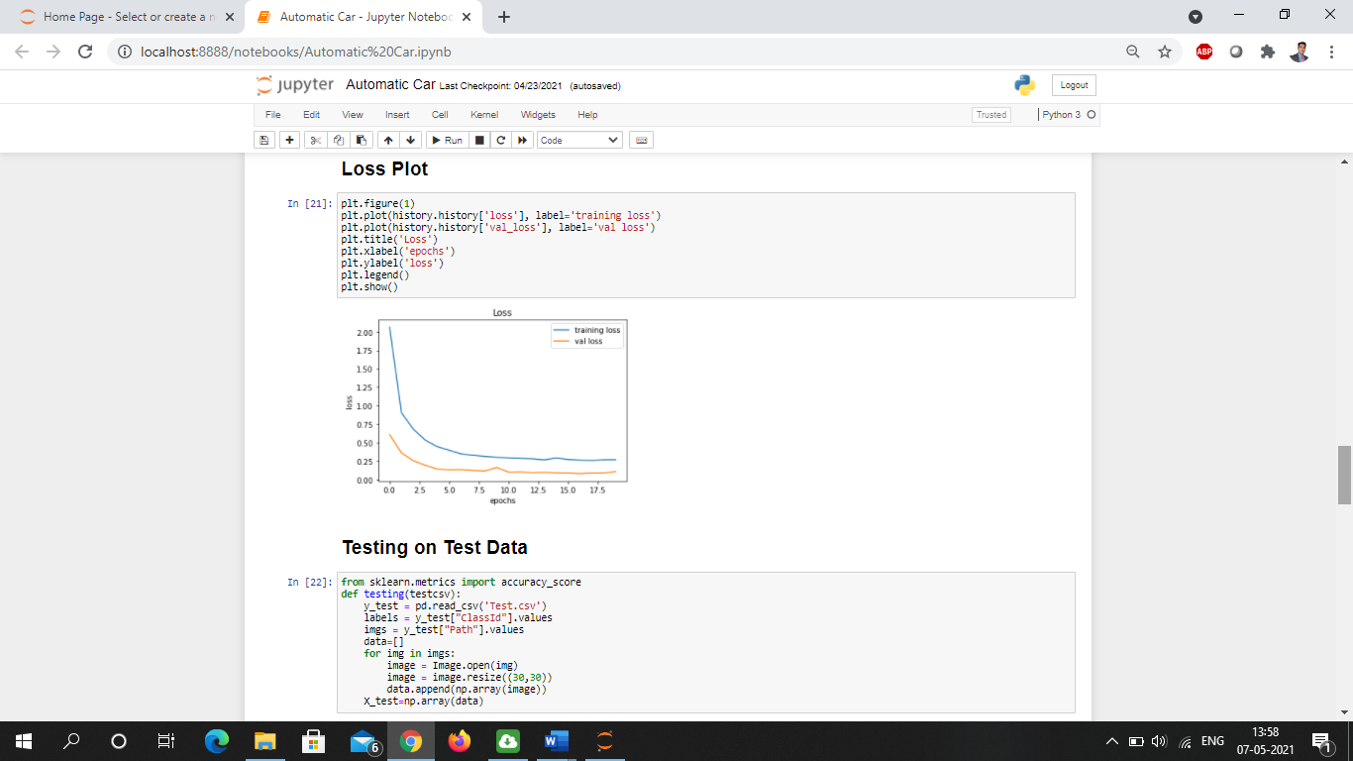

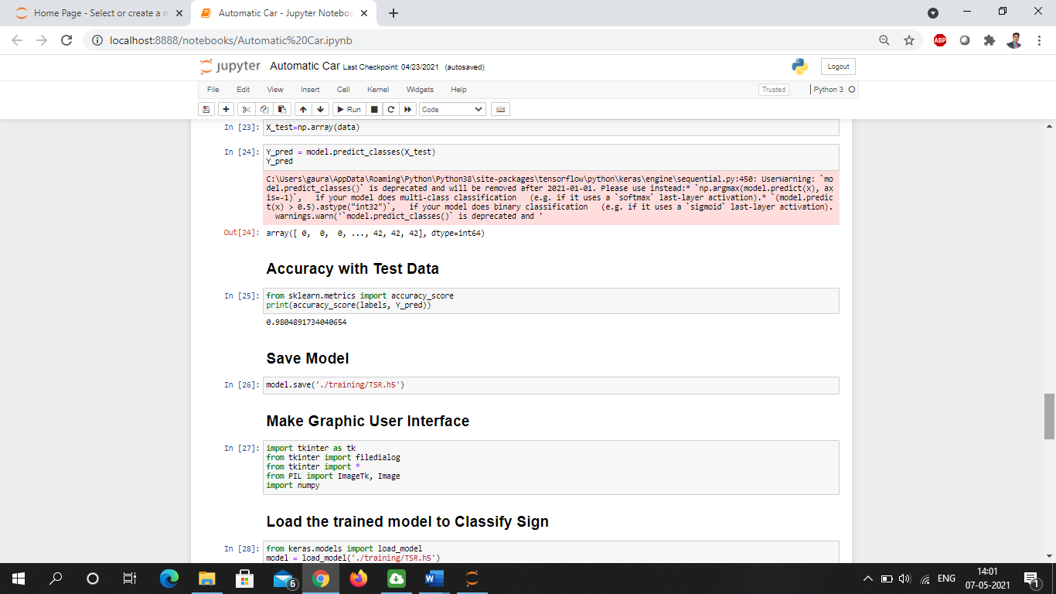

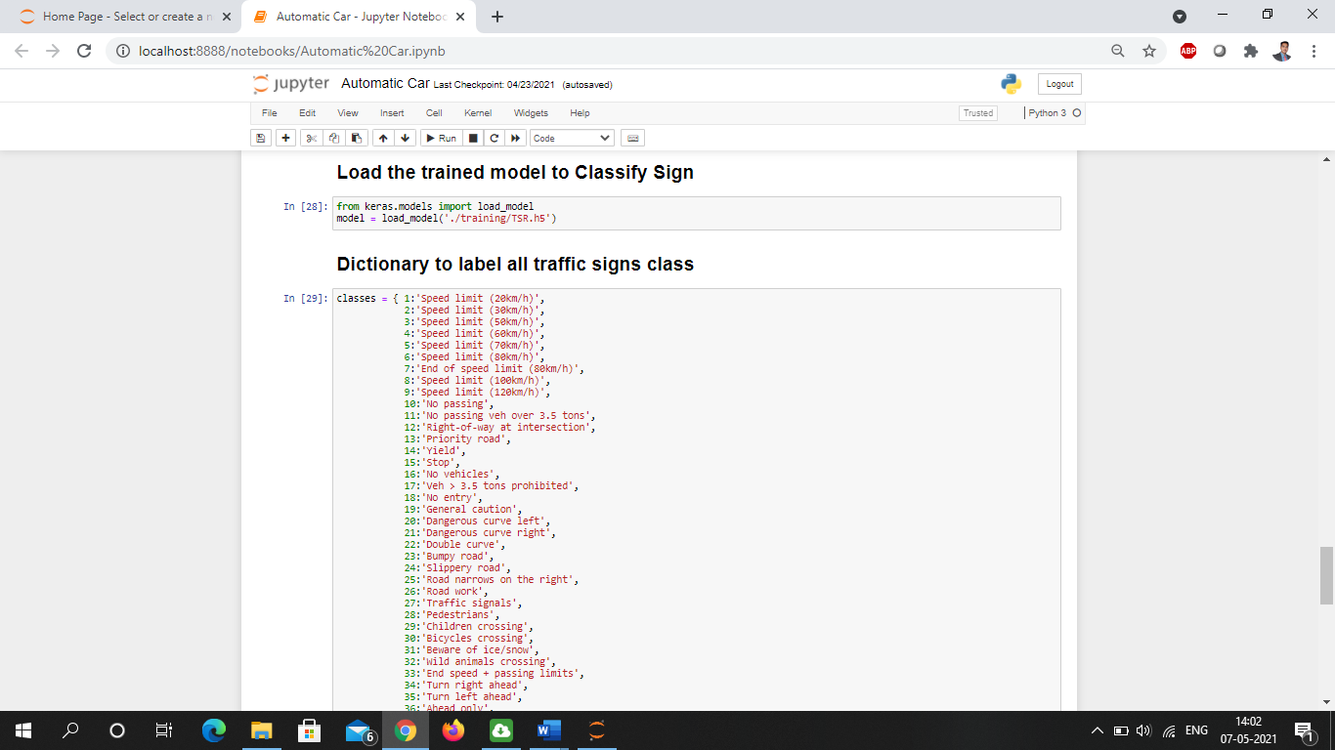

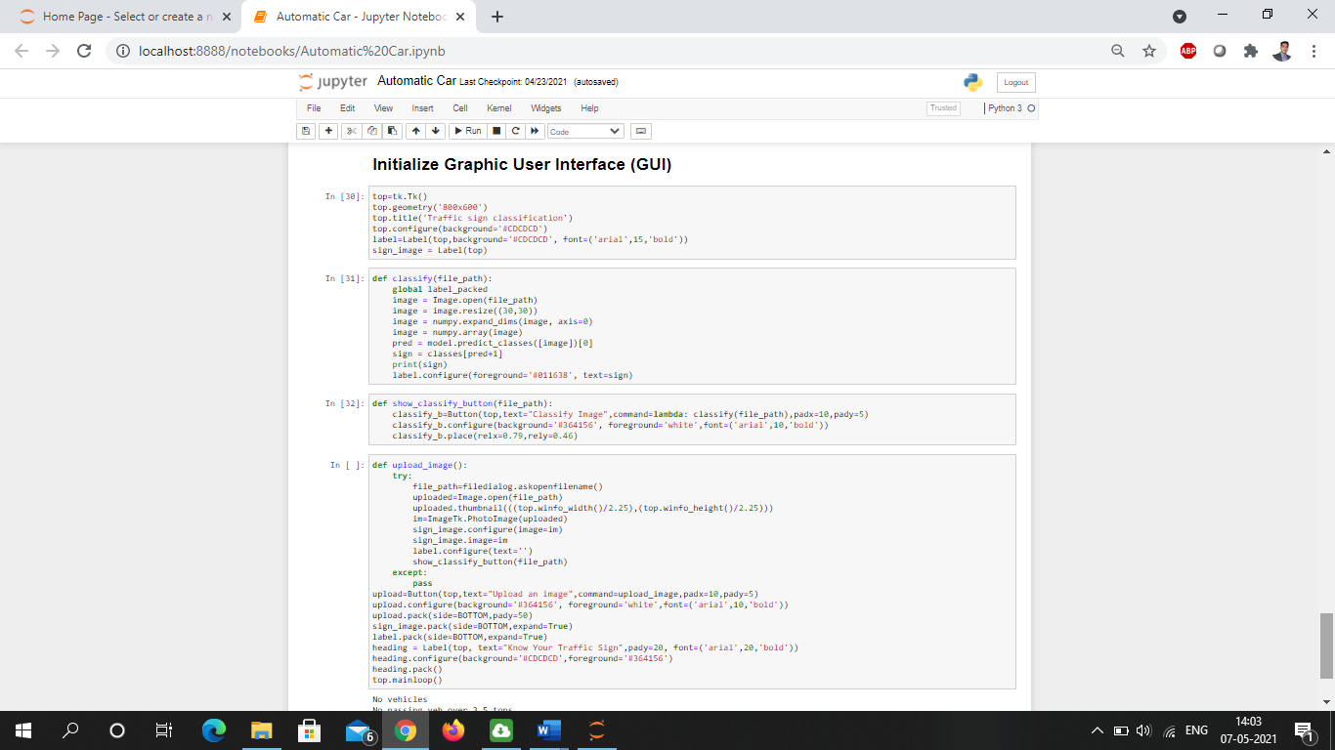

1. Reporting:

With the help of Business Intelligence Tools like Tableau and Power BI, we created interactive dashboards which help us visualize the data and draw insights from it.

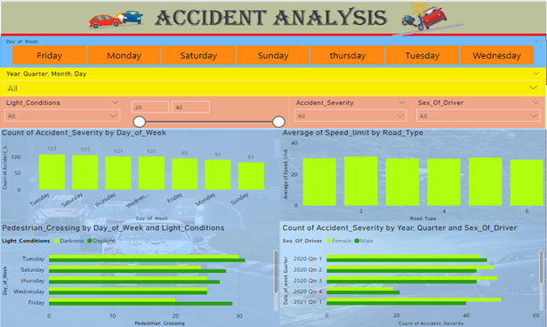

Power BI dashboard

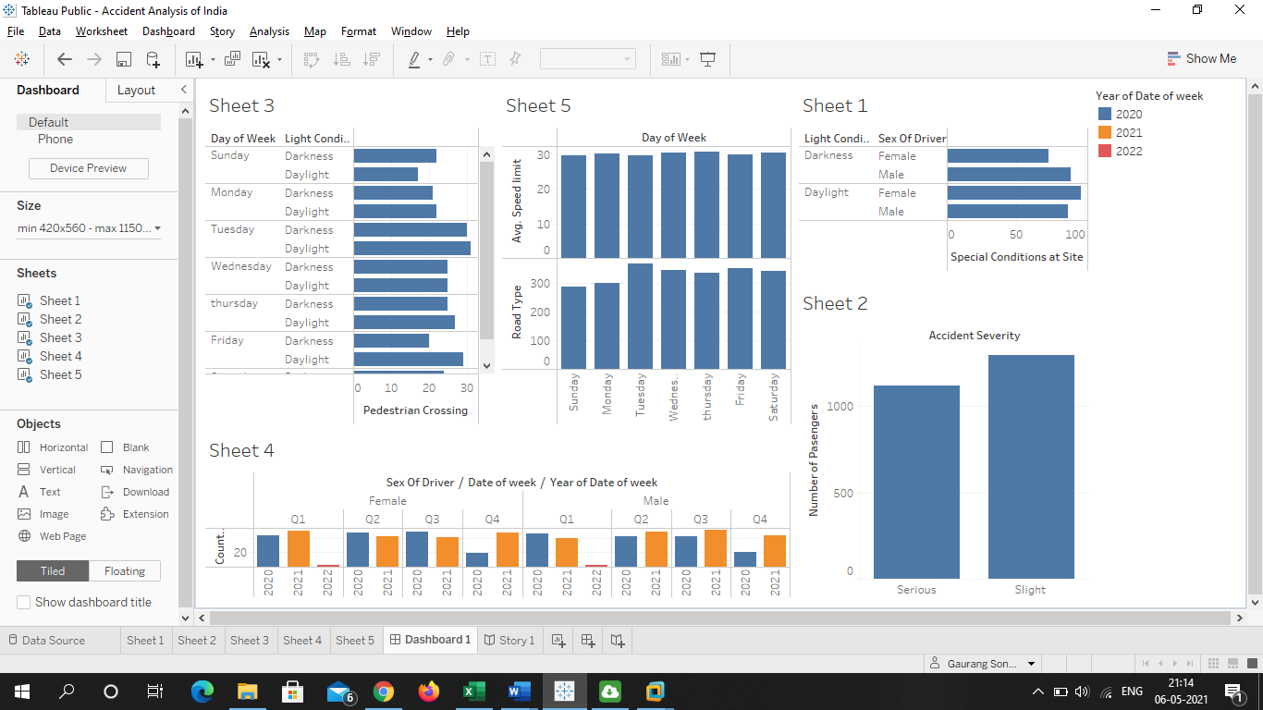

Tableau Public Dashboard

**5.**

**OUTPUT**

**GUI Representation**

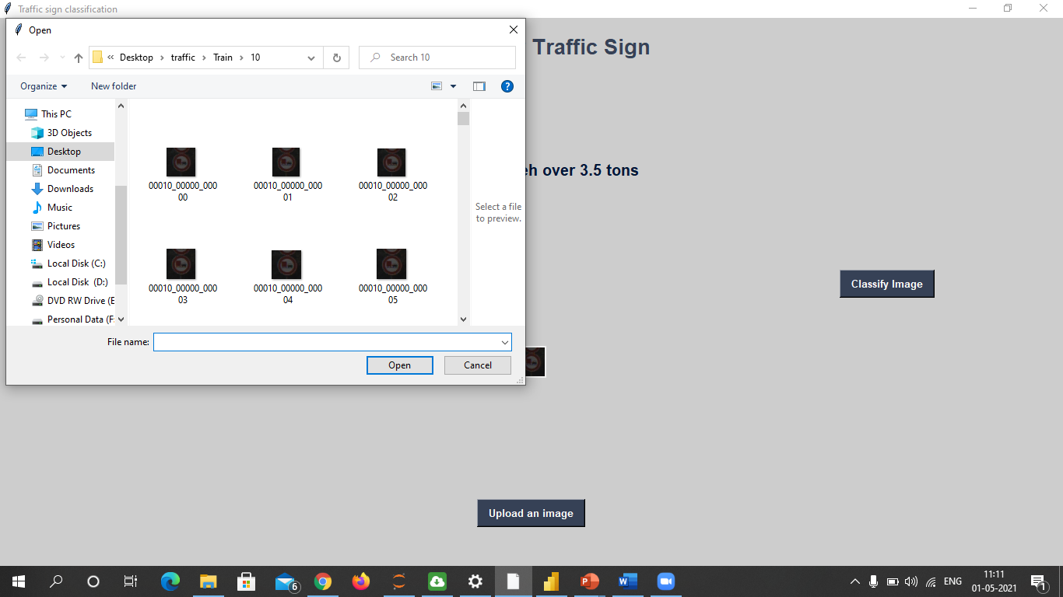

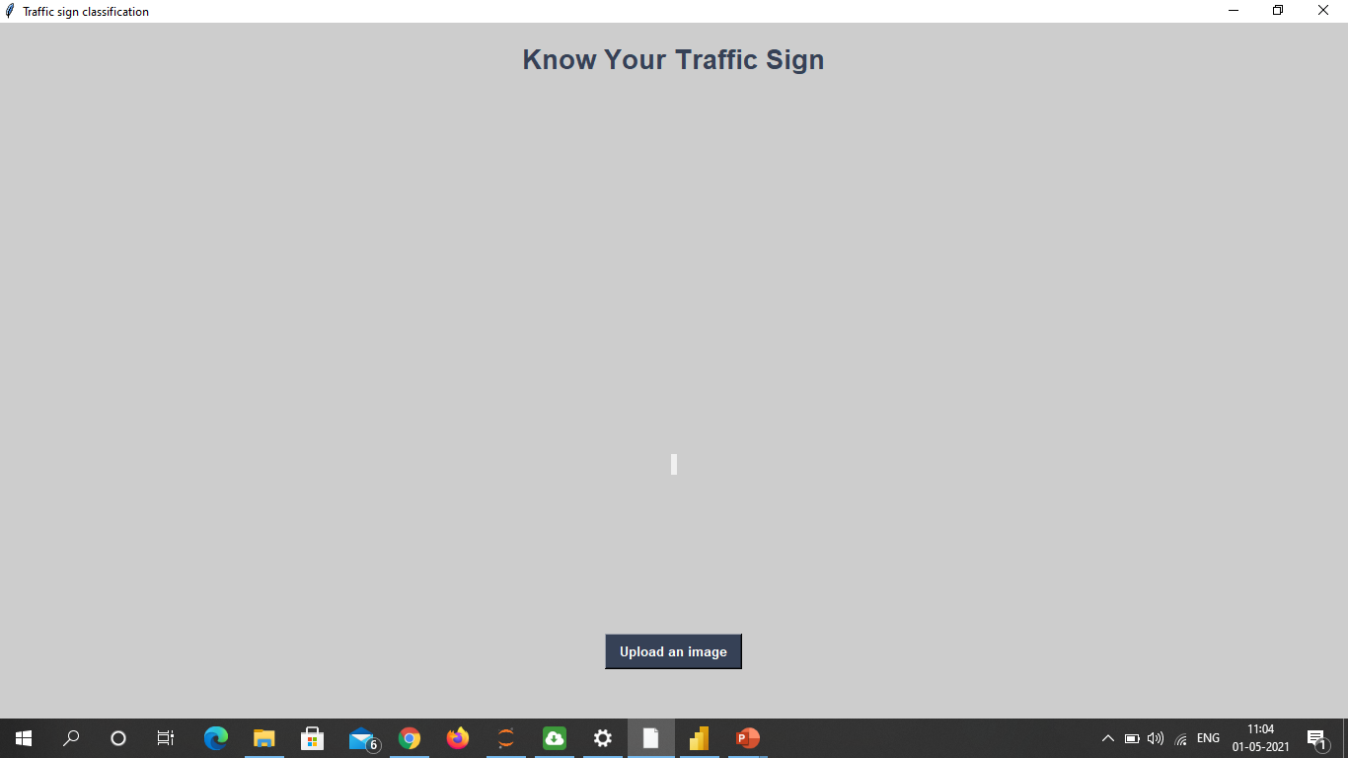

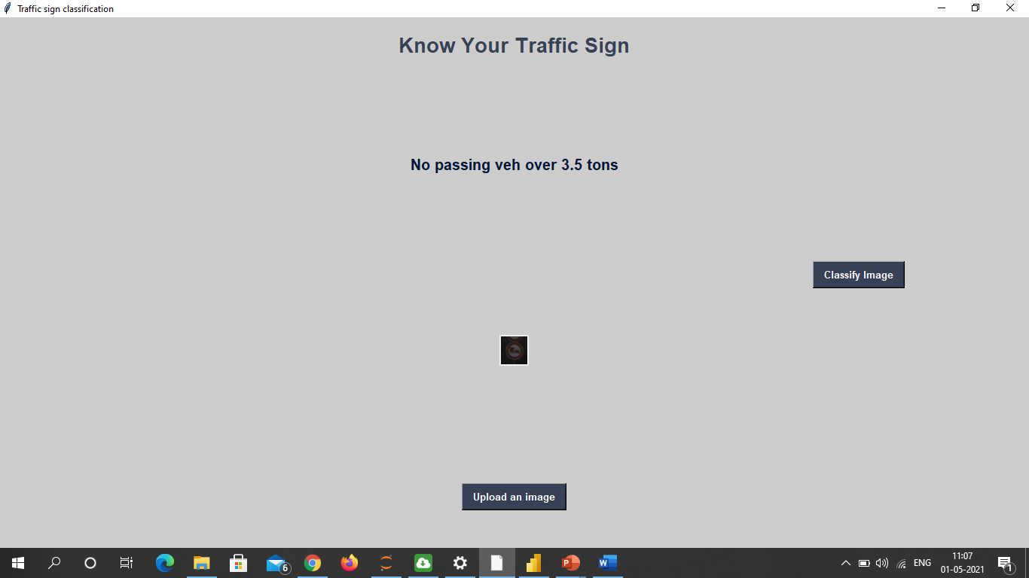

**6.**

**Future Scope And Conclusion**

**Future Scope**

This system can be improved to identify the traffic signs other than warning signs. In

this research work, we have used the Normalized RGB color space to identify the traffic

warning signs. By using Normalized RGB color space; detection of the Red color is also

possible. Therefore this color space can be used to identify the traffic signs with the Red color

outline also.

The techniques introduced in this report can be used as a basis for developing general

purpose, advanced intelligent traffic surveillance systems. By combining with character pattern

recognition process, our method can be extended to recognize the vehicle license plate number,

which has recently become an active research area. Extraction of the characters can be done by

changing the threshold values.

**Conclusion**

This paper considers an implementation of the classification algorithm for the traffic signs recognition task. Combined with preprocessing and localization steps from previous works, the proposed method for traffic signs classification shows very good results: 99.94 % of correctly classified images. The proposed classification solution is implemented using the TensorFlow framework. The use of our TSR algorithms allows processing of video streams in real-time with high resolution, and therefore at greater distances and with better quality than similar TSR systems have. FullHD resolution makes it possible to detect and recognize a traffic sign at a distance up to 50 m.